Task- List (Marshal)

Submitted in partial fulfillment of the requirements of

**Mini Project (CSM301)**

for

Second Year of Computer Engineering

By

**Omkar Patil 21102A0003**

**Deep Salunkhe 21102A0014**

**Sukant Thombare 21102A0037**

**Pranav Redij 21102A0005**

Under the Guidance of

Prof. Divya Surve

Department of Computer Engineering

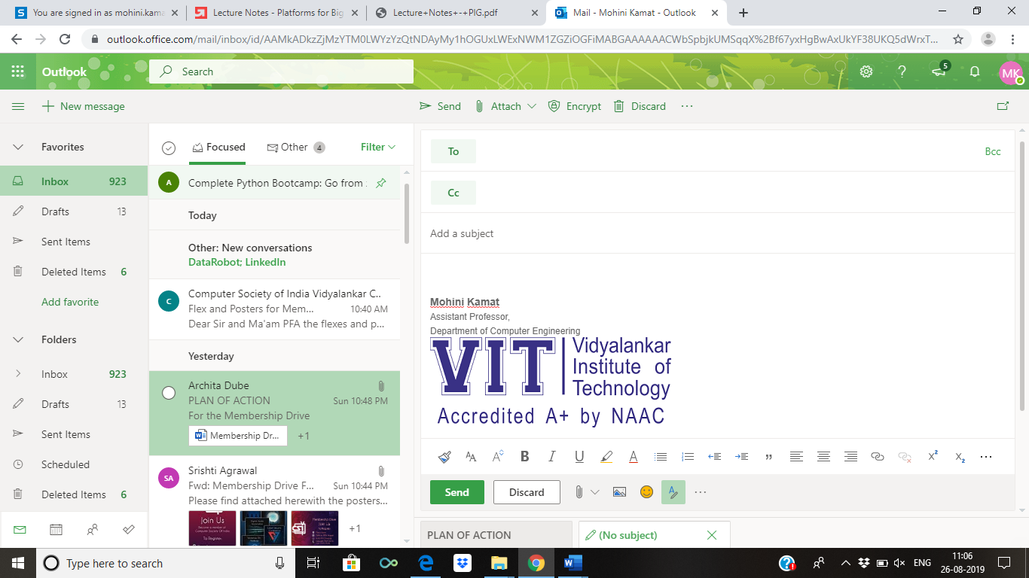

**(An Autonomous Institute Affiliated to University of Mumbai)**

Vidyalankar Institute of Technology

Wadala(E), Mumbai-400437

University of Mumbai

2022-23

**CERTIFICATE OF APPROVAL**

This is to certify that the project entitled

**“Task list(Marshal)”**

is a bonafide work of

**Omkar Patil 21102A0003**

**Deep Salunkhe 21102A0014**

**Sukant Thombare 21102A0037**

**Pranav Redij21102A0005**

submitted to the University of Mumbai in partial fulfillment of

**Mini Project (CSM301)**

for

Second Year of Computer Engineering

Guide Head of Department Principal

(Divya Surve)

Mini Project Report Approval

This project report entitled **“Task list(Marshal)”**by

1. **Omkar Patil 21102A0003**
2. **Deep Salunkhe 21102A0014**
3. **Sukant Thombare 21102A0037**
4. **Pranav Redij21102A0005**

is approved for Mini Project (CSM301) for Second Year of Computer Engineering.

|  |  |
| --- | --- |
| Internal Examiner | External Examiner |

Date:

Place:

Declaration

I declare that this written submission represents my ideas in my own words and where others' ideas or words have been included, I have adequately cited and referenced the original sources. I also declare that I have adhered to all principles of academic honesty and integrity and have not misrepresented or fabricated or falsified any idea/data/fact/source in my submission. I understand that any violation of the above will be cause for disciplinary action by the Institute and can also evoke penal action from the sources which have thus not been properly cited or from whom proper permission has not been taken when needed.

Name of student Roll No. Signature

1)Omkar Patil 21102A0003

2)Deep Salunkhe 21102A0014

3)Sukant Thombare 21102A0037

4)Pranav Redij 21102A0005

Date:

Place:

Acknowledgements

This Project wouldn’t have been possible without the support, assistance, and guidance of a number of people whom we would like to express our gratitude to. First, we would like to convey our gratitude and regards to our mentor **Divya Surve** for guiding us with his constructive and valuable feedback and for his time and efforts. It was a great privilege to work and study under his guidance.

We would like to extend our heartfelt thanks to our Head of Department, **Dr.Sachin Bojewar** for overseeing this initiative which will in turn provide every Vidyalankar student a distinctive competitive edge over others.

We appreciate everyone who spared time from their busy schedules and participated in the survey. Lastly, we are extremely grateful to all those who have contributed and shared their useful insights throughout the entire process and helped us acquire the right direction during this research project.

Abstract

In this project We have tried to create an applicattion that helps every indivudual to organise his/her day so that and make maximum out of it by staying organised

The purpose of this application is to

Goal to be achived application

* User must be able to plan his/her tasks using our application
* When the task is completed user can put a check mark on the respective task to get the sence of accomplisment
* Colaberate with other user when they are working as a team
* Users are able to chat with each other if required
* User should be able to make long terms goal(monthly) using our application
* User will get notification when user is near the dead line

**Table of Contents**

|  |  |  |
| --- | --- | --- |
| **Sr No** | **Description** | **Page No** |
| 1 | Introduction | 8 |
| 2 | Problem Definition | 9 |
| 3 | Literature Survey | 10 |
| 4 | Conclusion | 11 |
| 5 | References | 12 |

Introduction

The name marshall signifies person who arranges and directs the events,in our case that person is nothing but our own mini project for sem 3. This is divided into 4 major parts as follows login page, The login page allows a user to gain access to an application by entering their username and password or by authenticating using a social media login To do list, we have included this so that,By keeping such a list, you make sure that your tasks are written down all in one place so you don't forget anything important. Event Calendars are useful tools for keeping track of upcoming meetings, deadlines, and milestones. They can help you visualize your schedule and remind you of important events, such as holidays and vacation time. Chat rooms are Web sites or programs that allow people to send text messages to one another in real time.

Problem Definition

Many people don’t know what they want to do in daily life,daily goals help them to tackle this problem for that there was to do list.

Social media and other easily accessible online distractions make it hard for us to stay focused on our tasks and make it difficult for us to do our work efficiently.

Also, constantly switching between tasks may give us the false feeling that we are being productive when we are, in fact, not. It’s more important for us to prioritize tasks and work on those that are most important, rather than focusing on deleting small items from our todo list just for the sake of appearances.

The goal of this app is to help us become more aware of how we spend time in the process of doing those tasks and how productive that time is. It can help set some constraints on social media to reduce distraction and track the time we spend working on the todo items. When we have a better sense of the estimated time we’ll need to spend on our tasks, along with the validated time spent on the items for reference or personal/team reviews, we are able to manage our daily routines more efficiently.

Literature Survey

One of the most important reasons you should use a to do list is that it will help you stay organised. When you write all your tasks in a list, they seem more manageable. When you’ve got a clear outline of the tasks you’ve got to do and those you’ve completed, it helps you stay focused. While freeing up space in your mind for other more creative tasks.

When you complete a task, you can cross it off your list. This gives you a sense of progress and achievement, something you’ll lack if you’re always rushing from one task to the next. If you feel a sense of achievement, it spurs you on and motivates you to keep moving forward.

But that’s not the only benefit of a to do list.

Here are a few more:

* Improves your memory: A to do list acts as an external memory aid. It’s only possible to hold a few pieces of information at one time. Keep a to do list and you’ll be able to keep track of everything, rather than just a few of the tasks you need to do. Your to do list will also reinforce the information, which makes it less likely you’re going to forget something.
* Increases productivity: A to do list allows you to prioritize the tasks that are more important. This means you don’t waste time on tasks that don’t require your immediate attention. Your list will help you stay focused on the tasks that are the most important.
* Helps with motivation: To do lists are a great motivational tool because you can use them to clarify your goals. You can divide your long-term goal into smaller, more achievable short-term goals and as you tick each one off your list, your confidence will increase.

To do lists come in all shapes and sizes. It always used to be something that you would write using pen and paper, but thanks to technology there’s an app that can come to the rescue. What makes a good to do list app?

Tasks should be fast to add and organise

There should be a variety of ways to organise the tasks

Ability to plan your workflow

Setting priorities

Reminders for any self-imposed deadlines.

Allocation of tasks if using it for task management with a team.

Team to-do list allows you to assign to the best person for the job.

Able to sync between different platforms

All it takes is just a few minutes every day to keep a to do list up to date. With a to do list, you can complete goals without wasting time trying to figure out priorities. Your productivity will increase, you won’t forget things, your time management will improve and you’ll be able to manage your tasks more effectively.

With the mountain of tasks we have to do each day, we can't solely rely on our ability to remember them. To-do lists serve as a reminder for what you need to accomplish. When we check things off, it's proof that we were able to get stuff done and that makes us feel good.

So, Finally we find the referral for our innovation by the observing Microsoft To do list (Web Application).

Some Features that we Loved from this is:

* Collaboration features

Web/desktop application: While To Do started off as a mobile application, Microsoft has launched web and desktop versions for both Windows and Mac devices.

* Security features

Two-Factor Authentication (2FA): Microsoft allows you to set up additional identity verification through 2FA.

Single Sign-On (SSO) integrations: Microsoft To Do is part of the Microsoft cloud ecosystem, which allows it to take advantage of the SSO capabilities of Azure.

* Task prioritization and scheduler

This is the bread and butter of Microsoft To Do. Not only can you create main tasks, but also subtasks to help you track the intricacies of anything you’re looking to accomplish.

* Document storage

Microsoft To Do includes a file upload field in each individual task, including documents, images, and other types of files.

* File sharing

Not only does each Microsoft To Do task allow for a file upload feature, but each task is shareable with other app users.

* Budgeting features

There are no budgeting tools or features offered by this tool.

Tech-Stack

React is a popular open source front-end JavaScript library developed by Facebook. React is widely popular among developer communities because of its simplicity and easy but effective developing process. React makes it easier to create interactive user interfaces. It efficiently updates through rendering the exact components to the view of each state and makes the data changes in the application.

A React application is a collection of discrete components, each representing a single view. The idea of every individual view component makes it easy to iterate on product development because to make changes on a single view or component, it is not necessary to consider the entire system. When an application is built with React, the code is generally predictable, it is because React wraps the DOM mutative, imperative API with a declarative one, which raises the level of abstraction and simplifies the programming model. [1] Moreover, it is easier to scale the application built with React. The combination of React and the rapid iteration cycle of the web, has enabled to make some excellent products including many Facebook components. An amazing JavaScript framework called Relay has also been made on top of React, which helps simplifying data fetching on a large scale

. 

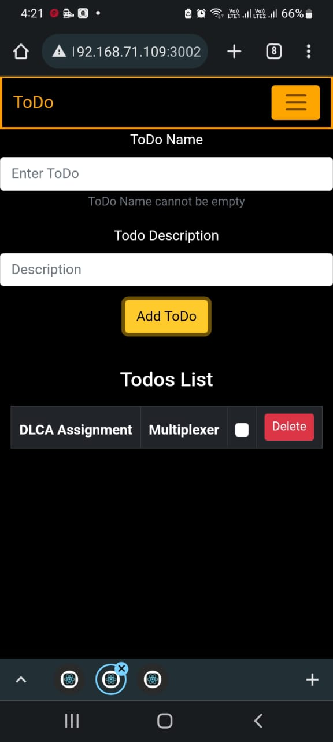Implementation

To-Do List :-

A list of tasks that need to be completed, typically organized in order of priority

It determines what you will get done and what you will remember to do.Some people keep lists of any and all task that come their way. Others only write down the few tasks they know they can do today. Some write down only the things they know will get done. Others write down what they completed and then immediately check the items off. (Kind of a reverse todo list.)You shouldn’t be afraid to add things to your list. Adding a task to your list shouldn’t be looked at as a burden or hard commitment. Rather, it is a way to track your tasks. Let your list remember your tasks, so that you don’t have to keep them all in your head.

Registration page /Login page:-

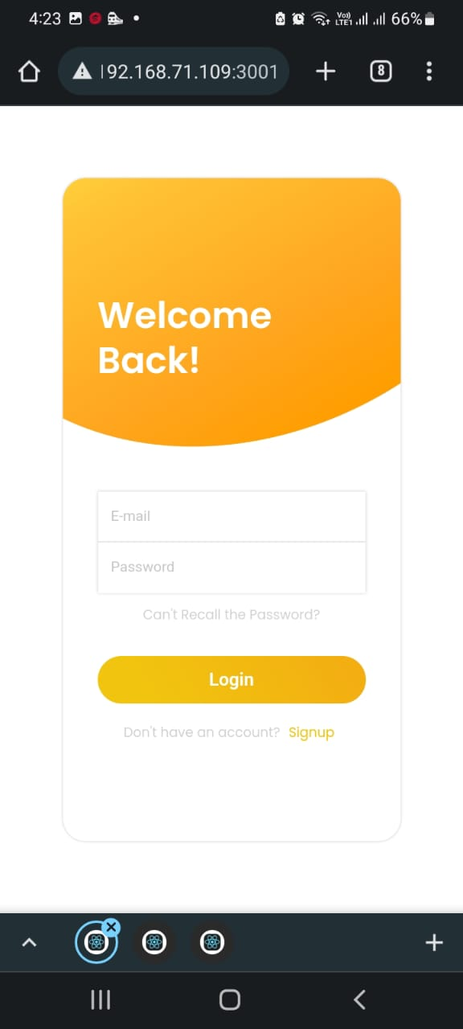A login page is one of the most important pages of a website/app that allows authorized users to access an entire site or a part of a website. For login protected sites, the login/sign up page is the very first page to show the users. Whether it’s a signup or login page, it should be attractive, user-friendly, and easy to use. The following is a simple login form that comes with a clean user interface to log in. This login form template has a title, input field for email & password. A login form generally consists of a username or email field, a password field and a bottom for logging in. Some of the login page may also include captcha which helps to prevent automated login attempts.

Calendar page :-

A **Calendar** is a chart or device which displays the date and the day of the week and often the whole of a particular year divided up into months, weeks, and days.

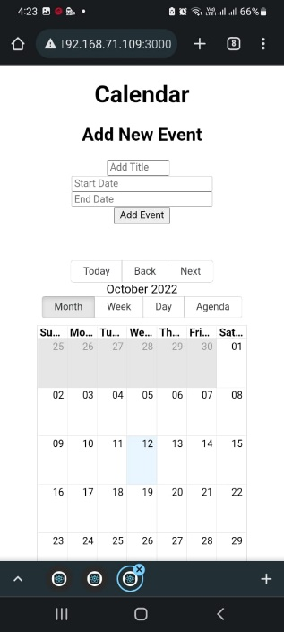Using this option User can plan there long term plans such as monthly goal

Chat Room :-

Chat Room Web free chat online with thousands of other people from all over the world. All chat rooms are simple and easy to use. Chat room users register for the chat room of their choice, choose a user name and password, and log into a particular room (most sites have multiple chat rooms). Inside the chat room, generally there is a list of the people 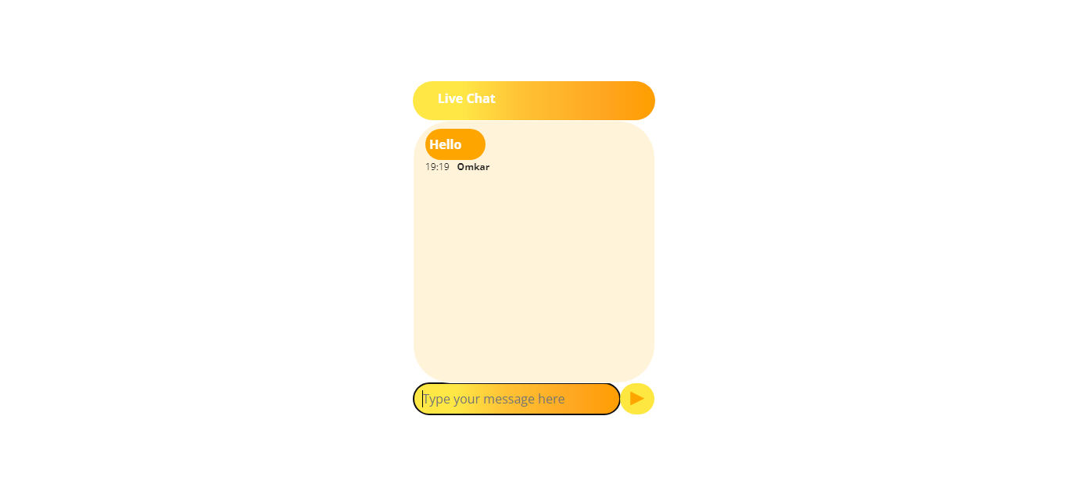currently online, who also are alerted that another person has entered the chat room. To chat, users type a message into a text box. The message is almost immediately visible in the larger communal message area and other users respond.

Future Scope

I perhaps could have benefitted from starting from a web site, because my target users are all the users who uses smart devices. Perhaps starting from a web site would give users a better sense of how the would work for them.

Also, if users want to keep doing the same task the next day, the current app doesn’t track the total time spent a project; in an attempt to break down the todos into small pieces, the app treats each todo as an individual daily task. But with some tasks falling into the same project, it might be valuable to offer a function that allows users to see how much time is spent in total on a project.

As this is web application this application is not ready for use ,as this is not connected to database we wish to connect this application to database in future, so it will fullfill its true use.

Conclusion

We are able to achieve following things due to this project, Without discipline, the life of a person will become dull and inactive. Also, a disciplined person can control and handle the situation of living in a sophisticated way than those who do not. Moreover, if you have a plan and you want to implement it in your life then you need discipline. It makes things easy for you to handle and ultimately bring success to your life.

In conclusion, we can say that discipline is one of the key elements of anyone’s life. A person can only be successful if she/he strictly live a healthy and disciplined life. Besides, the discipline also helps us in a lot of ways and motivates the person around us to be disciplined. Above all, discipline helps a person to achieve the success that she/he wants in life.

References

* React website: <https://reactjs.org/>
* Code with harry: <https://www.youtube.com/watch?v=RGKi6LSPDLU>
* Chat page:

<https://youtu.be/NU-HfZY3ATQ>

* <https://youtu.be/lyRP_D0qCfk>